ReactJS Hands on Exercise:

1. Install create-react-app:

npm create-react-app -g

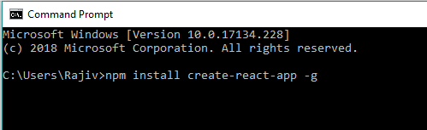

1. create-react-app <app-name>

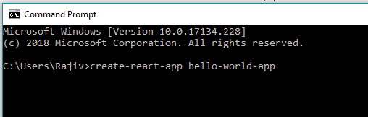

1. Navigate Inside the Folder hello-world-app
2. Run the application using npm start

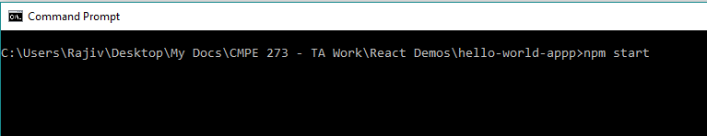

1. Open your Browser and go to localhost:3000
2. Now Open the Folder Inside VS Code. Replcae the App.js file code with the below code

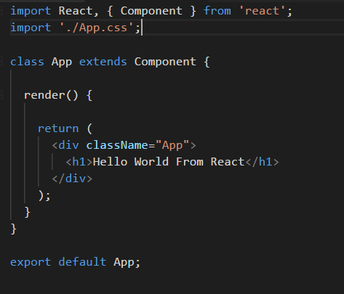

1. Now Visit the browser again to see the output